|  |  |  |  |  |  |  |
| --- | --- | --- | --- | --- | --- | --- |
| **REVISION HISTORY** | | | | | | |
| Revision | Description of Change | | Writer/Reviser | | Effective Date | |
| 0.1 | Initial Version | | Anthony-Hung Tran | |  | |
|  |  | |  | |  | |
|  |  | |  | |  | |
|  | | | | | |
| Author Name | | Title | | Department Name | |
| Anthony-Hung Tran | | OpenXC-Modem Connect PC App Installation Procedure | |  | |

**APPROVERS**

|  |  |  |  |  |
| --- | --- | --- | --- | --- |
| Name | Title | Department | Approval Status | Approval Date |
| Anthony-Hung Tran | Software Engineer |  |  |  |
|  |  |  |  |  |
|  |  |  |  |  |
|  |  |  |  |  |
|  |  |  |  |  |
|  |  |  |  |  |

**ABOUT FLEXTRONICS**

Flextronics is a leading Electronics Manufacturing Services (EMS) provider focused on delivering complete design, engineering and manufacturing services to automotive, computing, consumer, industrial, infrastructure, medical, clean tech and mobile OEMs. Flextronics helps customers design, build, ship, and service electronics products through a network of facilities in 30 countries on four continents. This global presence provides design and engineering solutions that are combined with core electronics manufacturing and logistics services, and vertically integrated with components technologies, to optimize customer operations by lowering costs and reducing time to market.

Table of Contents

1 INTRODUCTION 3

1.1 Scope and Purpose of the document 3

1.2 Intended Audience or Applicability 3

2 INSTALLATION PROCEDURE 4

3 REVIEW CHECKLIST 11

# INTRODUCTION

This document describes OpenXC Modem Connect PC Application Installation procedure.

## Scope and Purpose of the document

This document demonstrates installation procedure of OpenXC Modem Connect PC Application which would automatically detect OpenXC Modem connectivity to the PC then open or close TeraTerm (or other configured terminal application) on the proper port accordingly.

## Intended Audience or Applicability

This document is intended for team members/users who need to install terminal application to connect with an OpenXC Modem

# INSTALLATION PROCEDURE

1. Download the installation package (ModemConnect-v1.0.0.143.msi) into your PC and invoke the setup wizard.

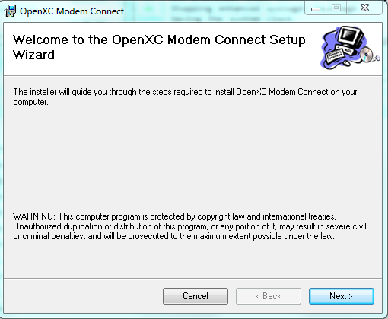

Figure 1

1. You might also select to install TeraTerm installation as well.

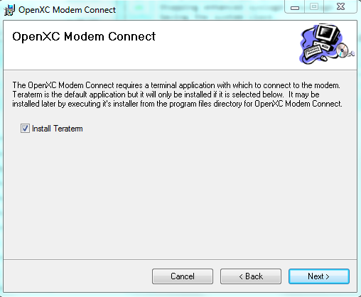

Figure 2

1. Follow on-screen instructions to select installation options as needed.

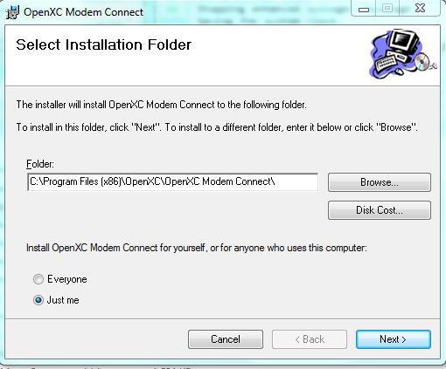

Figure 3

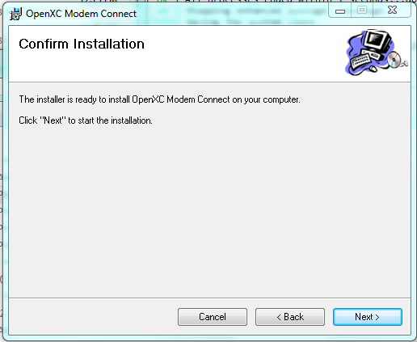

Figure 4

1. If TereTerm installation option is selected, please follow TeraTerm Setup Wizard instructions to proceed accordingly

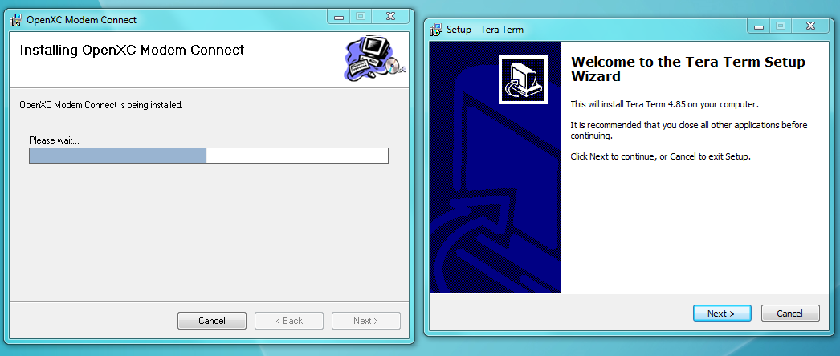

Figure 5

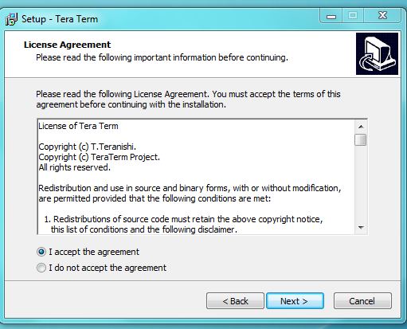

Figure 6

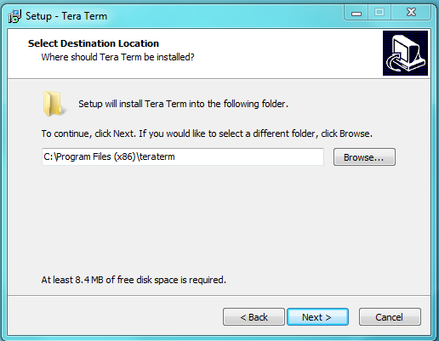

Figure 7

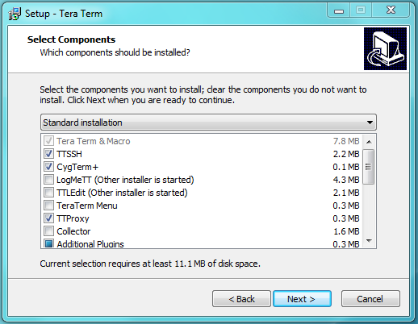

Figure 8

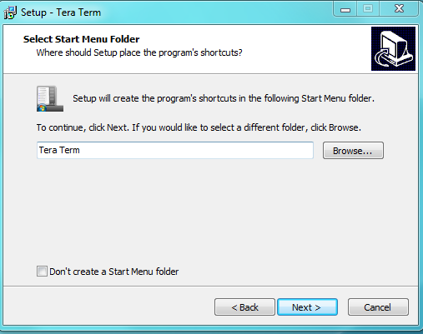

Figure 9

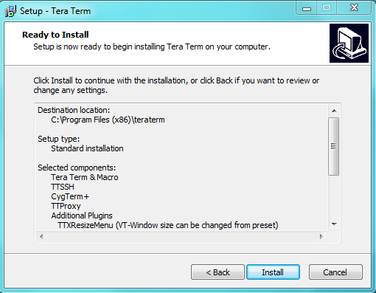

Figure 10

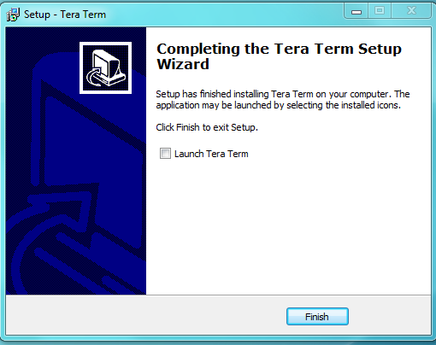

Figure 11

1. You can close the setup wizard after the installation is completed.

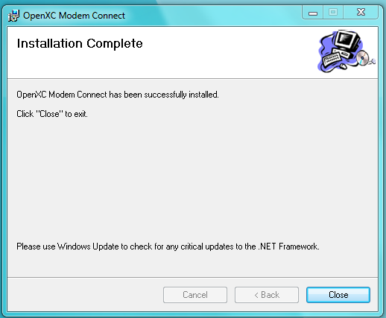

Figure 12

1. Modem Connect without OpenXC Modem connection or the connection hasn’t yet ready

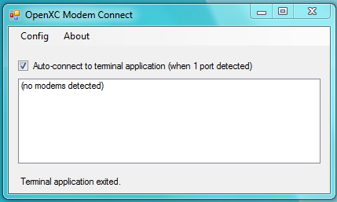

Figure 13

1. Modem Connect once the connection is ready. You might need to press Enter to obtain log-in prompt

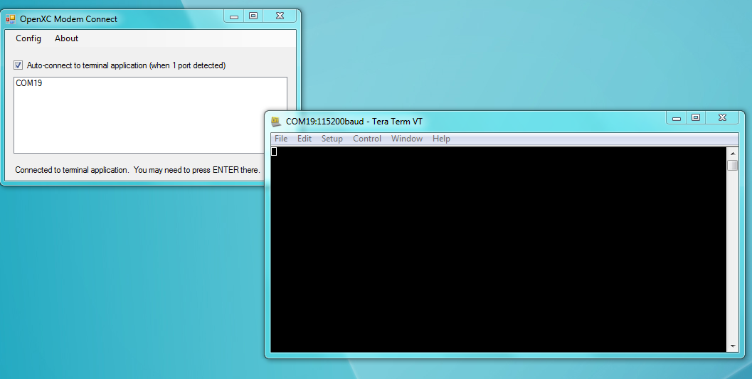.

Figure 14

# REVIEW CHECKLIST

This document should be reviewed using the below checkout.

|  |  |  |  |  |
| --- | --- | --- | --- | --- |
| **Number** | **Checklist Item** | **Reviewer Name** | **Reviewed Yes/ No** | **Review Comments** |
|  |  |  |  |  |
|  |  |  |  |  |
|  |  |  |  |  |
|  |  |  |  |  |
|  |  |  |  |  |
|  |  |  |  |  |
|  |  |  |  |  |